**UHO**

United Health Organization

**Integration Technical Design Document**

**who-sapi technical design**

|  |  |  |
| --- | --- | --- |
| **Project/Service Identifier:** |  | who system API |
| **Prepared By:** | Chinna Reddy |
| **Document Version:** | Version 1.0.0 |
| **Published Date:** | 2021/08/12 |

**Revision History**

|  |  |  |  |
| --- | --- | --- | --- |
| **Version Number** | **Revision Date** | **Summary of Changes** | **Modified by** |
| 0.1 | *2021/08/12* | Initial document created | *Chinna Reddy* |
|  |  |  |  |
|  |  |  |  |
|  |  |  |  |
|  |  |  |  |

**Contributors**

| **Name** | **Title** |
| --- | --- |
| *Chinna Reddy* | *Mulesoft Technical Architect* |
|  |  |
|  |  |
|  |  |

**Distribution & Reviewers**

| **Name** | **Title** |
| --- | --- |
| *Technical Reviewer* | *TBD* |
| *QA Reviewer* | *TBD* |
| *Architecture Reviewer* | *TBD* |
| *PM* | *TBD* |

**Approvals**

|  |  |  |  |
| --- | --- | --- | --- |
| **Interface ID** | **Interface Name** | **Approval Given On** | **Approver(s)** |
| **1** | **publish-covid-case-to-who** | **TBD** | **TBD** |
|  |  |  |  |
|  |  |  |  |
|  |  |  |  |
|  |  |  |  |
|  |  |  |  |
|  |  |  |  |

**Table of Contents**

1 Introduction 1

1.1 Document Overview 1

1.1.1 Intended Audience 1

1.1.2 Structure 1

1.1.1 Related Documents 1

2 Technical Architecture 2

3 Services/APIs High level Specification 3

3.1 upload-s3-document : https://uho-{env}-aws-sapi/v1/document 3

3.1.1 Input and Output Definitions of API 3

3.1.2 Consumers 4

3.1.3 Technical details 4

3.1.4 Non Functional 4

3.1.5 Error Handling 5

3.1.6 Integration test cases 5

3.1.7 API Endpoint Details 5

4 API Policies, Access and Network Security - TBD 6

5 Open Issues 7

6 Appendix A – Interface details 8

# Introduction

## Document Overview

### Intended Audience

This document is intended to be used by the integration developers, Integration support team, architects, and testers who will be designing, implementing, and maintaining these middleware services. This document is not intended to be used by the API consumers; API documentation is provided on the Anypoint platform.

### Structure

This document contains an overview and depiction of all the services. Document includes detailed designs for each service, including intended API consumers, business rules, technical considerations, and result codes.

### Related Documents

The following list provides links to related documents:

|  |  |  |
| --- | --- | --- |
| Document | Intended Use | Share point Link |
| Solution Architecture Document |  |  |
| Data Mapping document |  |  |

# Technical Architecture

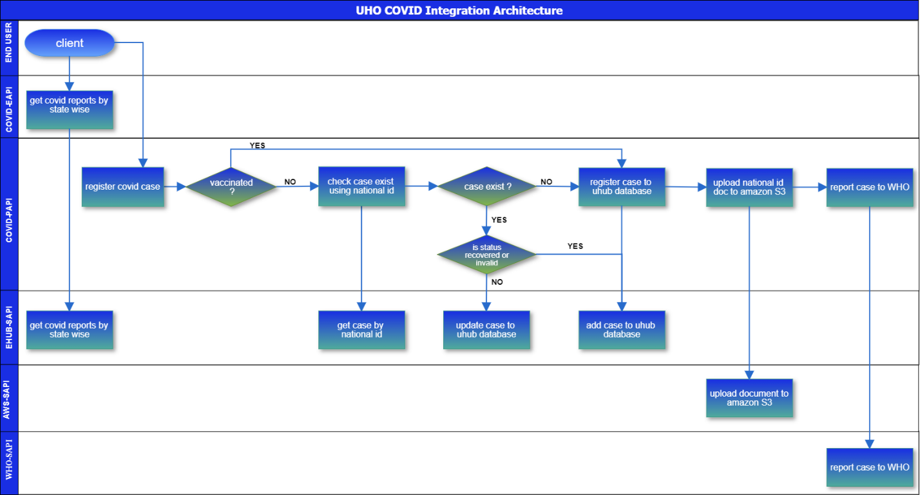

# Services/APIs High level Specification

## publish-covid-case-to-who : https://uho-{env}-who-sapi/covid/v1/case

This is a POST based API allows COVID case JSON payload as input then transforms to XML payload then published to WHO JMS queue and responds back 200, Success. On failure the API will respond back corresponding error code and message along with description.

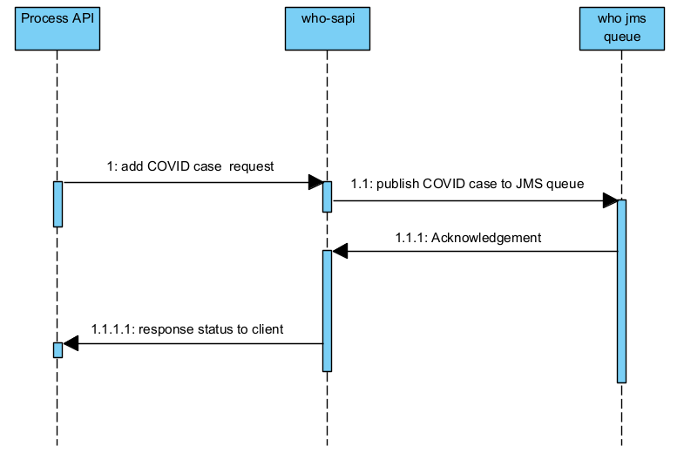

1. The process API’s consumes who-sapi.
   1. The who-sapi publish COVID case to WHO JMS queue..
      1. WHO JMS queue responds back generated acknowledgement.

1.1.1.1 The who-sapi API responds back client.

### Input and Output Definitions of API

**Input:**

{

   "caseType":"positive",

   "firstName":"John",

   "lastName":"Nixon",

   "phone":"541-754-3010",

   "email":"john@gmail.com",

   "dateOfBirth":"1989-04-26",

   "country":"USA"

}

**Output: 200, Success**

{

   "code": 200,

   "message": "Success",

   "description": "Case reported successfully",

   "dateTime": "2021-07-29T05:58:02Z",

   "transactionId": "44b32520-61ee-47b4-907d-fa15869f3c4d"

}

WHO queue name: Q.WHO.COVID.CASE.REPORT

WHO queue payload:

<?xml version="1.0" encoding="UTF-8"?>

<COVID_CASE>

   <FIRST_NAME>John</FIRST_NAME>

   <LAST_NAME>Nixon</LAST_NAME>

   <PHONE>541-754-3010</PHONE>

   <EMAIL>john@gmail.com</EMAIL>

   <DATE_OF_BIRTH>1989-04-26</DATE_OF_BIRTH>

   <COUNTRY>usa</COUNTRY>

</COVID_CASE>

Dynamic properties: CASE_TYPE

### Mapping



### Consumers

|  |  |  |
| --- | --- | --- |
| API Consumer | Description | |
| Experience API’s / Process API’s | | Process API’s consumes who-sapi services to publish COVID case to WHO queue. |
| Other UHO applications | | UHO applications can consume who-sapi services to publish COVID case to WHO queue. |

### Technical details

|  |  |
| --- | --- |
| API Name | who-sapi |
| Business Requirements | As mentioned in integration solution document |
| API Communication Type | REST |
| Interface Pattern | Request/Reply |
| Interface Definitions | RAML API Specification |
| Sample Request | JSON(Section 3.1.1) |
| Sample Response | JSON(Section 3.1.1) |

### Non Functional

|  |  |
| --- | --- |
| Post Execution Notification Details | Data-Related Failures Handling:  Currently all the errors will be logged into logs with log4j.  Consumer API is responsible to log about error details.  Can be visible in runtime manager.  Technical Errors Handling:  Currently all the errors will be logged into logs with log4j.  Consumer API is responsible to log about error details.  Can be visible in runtime manager. |
| Process Log Audit Details | Audit & Logging:  Created Logs for the following   * Request message at entry point * Request message at system call entry point * Request message at system call entry point * Request completed |

### Error Handling

|  |  |  |
| --- | --- | --- |
| No. | Type of Exception | Exception Handling |
| 1 | Any technical issue | * API shall respond corresponding response message. * API will record the error in logs. * Runtime manager notifications will be configured - TBD * Application Administrative team will be notified using an email notification service- TBD |

### Integration test cases

| **Description** | **Result** |
| --- | --- |
| Successful case registration | 200 - Success |
| System connectivity failure (Database is down) | 503 - The (upstream) service is temporarily not available |
| Invalid JSON payload request | 400 – Bad request |
| Internal server error | 500 – Internal server error |
| API Kit Router errors | Global errors |

### API Endpoint Details

| **Requirement** | **Method** | **Details** |
| --- | --- | --- |
| **Development** | POST | <https://uho-dev-who-sapi/covid/v1/>case |
| **Test** | POST | <https://uho-test-who-sapi/covid/v1/>case |
| **UAT** | POST | <https://uho-uat-who-sapi/covid/v1/>case |
| **Production** | POST | <https://uho-prod-who-sapi/covid/v1/>case |

# API Policies, Access and Network Security

|  |
| --- |
| Define API policies to be configured / customized |

| **Requirement** | **Details** |
| --- | --- |
| Access to APIs - Authentication | client_id enforcement |
| API Policy | CORS should be enabled |
| Communication over API’s | x-transaction-id and correlation-id |

# Open Issues

|  |  |
| --- | --- |
| **No** | **Open Issues** |
| 1.0 |  |
|  |  |

# Appendix A – Interface details

WSDLs

Exported RAMLs

Tables outlining data design